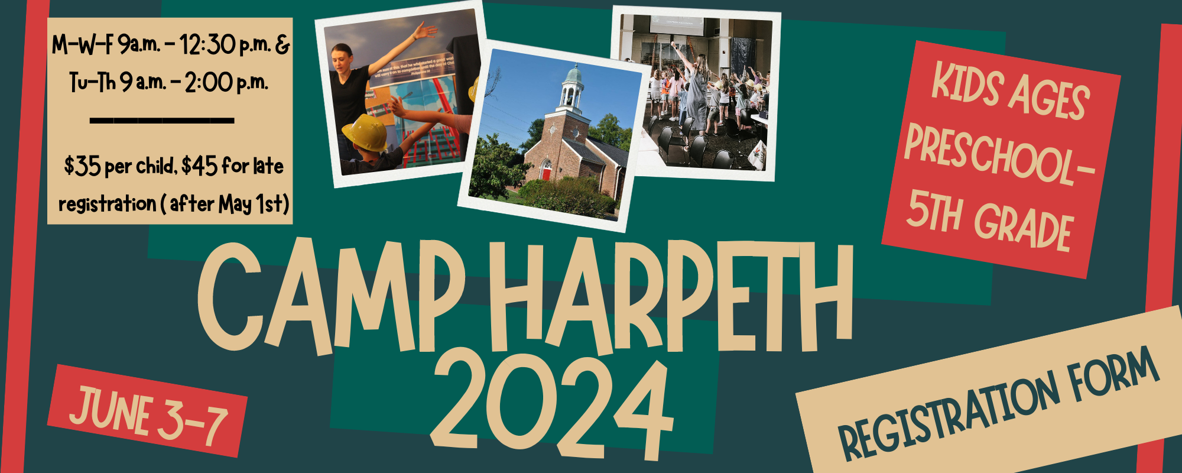

Child’s Name_____________________________ Age __________ Birthdate: _________________ Parent/Guardian Name _____________________________________________________________ Address __________________________________________________________________________ City/State/Zip _____________________________________________________________________ E-mail Address ____________________________________________________________________ Phone Numbers: Home _________________ Cell ________________ Work ___________________
In the Fall of 2024, camper will be: Pre-school _____ Entering Kindergarten_____ Entering 1st: ____ Entering 2nd: ____ Entering 3rd: ____ Entering 4th _____ Entering 5th: ____ T-shirt size: ________________
Allergies/Medical Information/Other Conditions That May Limit Activity:
__________________________________________________________________________________
Emergency Contacts:
Name___________________Phone______________Name___________________Phone___________
Dismissal Information:
Name(s) and phone number of person(s) who may pick up this child from VBS
________________________________________ _________________________________________
- I understand that photos may be taken and used for promotional purposes for Harpeth Presbyterian Church.
- My child has permission to participate in any and all activities at Harpeth VBS. I agree to assume the risks for any accidents incurred during this week.
Parent’s Signature: ___________________________________ Date: ________________________
Checks ($35 p/camper) can be made out to Harpeth Presbyterian Church with Camp Harpeth or VBS in the memo line.
If you have additional questions, please contact James Peeler (jamespeeler@bellsouth.net) or the church office (615) 373-8386 or office@harpethpresbyterianchurch.org).
We will be capping the number of campers at a safe number.
*Registration form available at: www.harpethpresbyterianchurch.org/camp-harpeth

